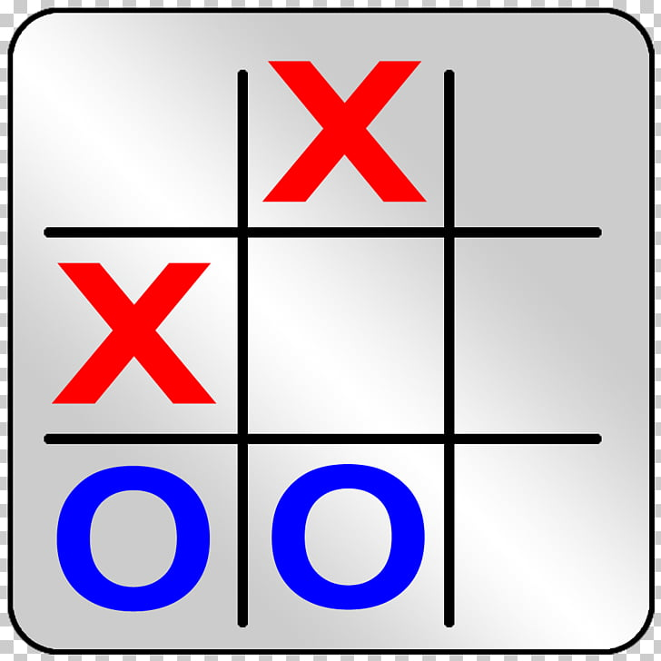

Project plan

OXO GAME



March 25, 2019

by BHEKANANI cELE & MATTHEW wEPPENAAR

# Introduction

We the development team are developing an OXO game for Ten Eleven Games. We, the team will provide progress on the game as specified in the schedule below. The game is played on different computers by different players at the same time. The game connects to a sever, which gets instructions from each player and process them. The player can start a new game, place a new move and close or quit the game.

# Purpose

The main focus of this plan is to clearly and logically layout the objective and goals of the development team. This will take the form of deliverables. This plan will explicitly detail who must perform a certain task related to the completion of the deliverables, and the time constraints connected to these tasks.

# Development team

Hafeni Mthoko(Leader)

Bhekanani Cele

Matthew Weppenaar

|  |  |  |  |  |
| --- | --- | --- | --- | --- |
| **Task** | **To Be Done By** | **Duration** | **Start Date** | **End Date** |
| 1. Text-based client | B.Cele & M.Weppenar | 5 days | 01/04/2019 | 06/04/2019 |
| * 1. Create option for user to enter server they want to connect to | M.Weppenar | 2 days | 01/04/2019 | 02/04/2019 |
| * 1. Create an empty block for user move | B.Cele | 2 days | 01/04/2019 | 02/04/2019 |
| * 1. Display board to user at appropriate times | B.Cele | 1 day | 03/04/2019 | 03/04/2019 |
| * 1. Display appropriate information to user e.g. instructions | M.Weppenar | 1 day | 03/04/2019 | 03/04/2019 |
| * 1. Ask user to play again, if the game is over. | B.Cele | 1 day | 04/04/2019 | 05/04/2019 |
| 1. GUI Prototype | B.Cele & M.Weppenar | 5 days | 08/04/2019 | 12/04/2019 |
| * 1. Low-fidelity prototype | M.Weppenar | 1 day | 08/04/2019 | 08/04/2019 |
| **Task** | **To Be Done By** | **Duration** | **Start Date** | **End Date** |
| * 1. High-fidelity prototype | B.Cele | 3 days | 09/04/2019 | 11/04/2019 |
| 1. Final System Alpha | B.Cele & M.Weppenar | 14 days | 15/04/2019 | 27/04/2019 |
| * 1. User Evaluation | M.Weppenar | 5 days | 15/04/2019 | 20/04/2019 |
| * + 1. Feedback from tutor and 2 other two Com-Sci students. | M.Weppenar | 3 days | 15/04/2019 | 18/04/2019 |
| * + 1. Feedback from 2 non-Com-Sci students. | M.Weppenar | 2 days | 18/04/2019 | 20/04/2019 |
| * 1. Allow both users to connect to the server. | B.Cele | 2 days | 15/04/2019 | 17/04/2019 |
| * 1. Interfaces handles the ‘new game’ message appropriately. | B.Cele | 3 days | 18/04/2019 | 21/04/2019 |

| **Task** | **To Be Done By** | **Duration** | **Start Date** | **End Date** |
| --- | --- | --- | --- | --- |
| * 1. Ensure game loop [play_loop()] runs in a separate thread, so as to not conflict with PyQt event loop. | B.Cele & M.Weppenar | 4 days | 22/04/2019 | 26/04/2019 |
| 1. Final System Beta | B.Cele & M.Weppenar | 6 days | 29/04/2019 | 04/05/2019 |
| * 1. Each team member implements a separate feature | B.Cele & M.Weppenar | 2 days | 29/04/2019 | 30/04/2019 |
| * 1. Complete system - fully functional gui-based OXO game GUI client | B.Cele & M.Weppenar | 3 days | 01/05/2019 | 03/05/2019 |
| 1. Final Report | B.Cele & M.Weppenar | 7 days | 03/05/2019 | 12/05/2019 |
| * 1. Introduction: Background, expectations and requirements | M.Weppenar | 1 day | 03/05/2019 | 04/05/2019 |
| * 1. Project Management: | B.Cele & M.Weppenar | 1 day | 04/05/2019 | 05/05/2019 |
| **Task** | **To Be Done By** | **Duration** | **Start Date** | **End Date** |
| * + 1. Project Plan: tasks schedule. | M.Weppenar | 1 day | 04/05/2019 | 05/05/2019 |
| * + 1. Teamwork: Working together and division of work | B.Cele | 1 day | 04/05/2019 | 05/05/2019 |
| * 1. Design: Low and High Fidelity, final user interface design and messaging protocol | B.Cele | 1 day | 06/05/2019 | 07/05/2019 |
| * 1. Implementation: Describe what was implemented and include screenshots. | M.Weppenar | 1 day | 06/05/2019 | 07/05/2019 |
| * 1. Testing: testing for correctness and user testing. | M.Weppenar | 1 day | 08/05/2019 | 09/05/2019 |
| * 1. Correctness: show what scenarios were used, why they were chosen, and the results. | B.Cele | 1 day | 08/05/2019 | 09/05/2019 |
| **Task** | **To Be Done By** | **Duration** | **Start Date** | **End Date** |
| * 1. User Testing: How well the users, used the system. What were their problems? | M.Weppenar | 1 day | 10/05/2019 | 11/05/2019 |
| * 1. Enhancements: enhancements made. | B.Cele | 1 day | 12/05/2019 | 12/05/2019 |
| * 1. Future Work: enhancements which could add to the user experience. | M.Weppenar | 1 day | 12/05/2019 | 12/05/2019 |